**基于Digilent® Nexys 3™开发板的**

**RISC指令集CPU设计**

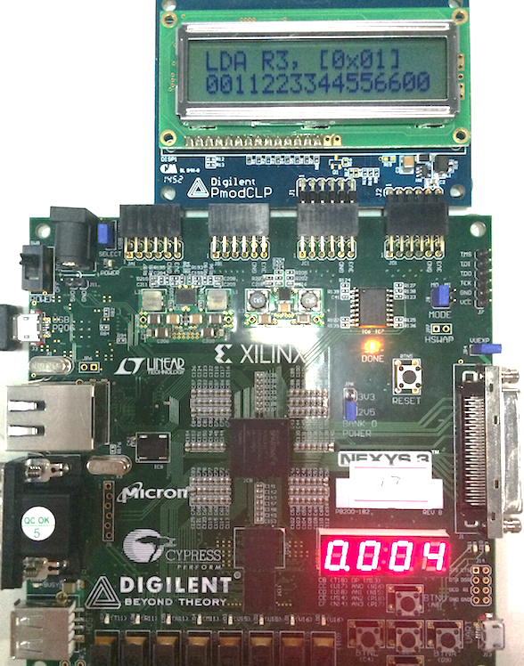

**作者：杨志飞**

**学号：1130310217**

**2013级计算机科学试验班（1336101）**

**计算机科学与技术学院**

**哈尔滨工业大学**

目录

前言 3

CPU结构介绍 3

1. 时钟管理模块CLK 3

2. 取指管理模块IF 3

3. 运算管理模块EX 4

4. 存储管理模块MEM 5

5. 回写管理模块WB 5

6. 访存控制模块AC 6

7. 主模块CPU 6

8. 按键防抖模块btnDebounce 7

9. IO转换模块IOConv 7

10. 七段数码管显示模块segDisplay 8

11. PmodCLP显示模块PmodCLP 9

12. 总模块N3Adapter 9

实现与仿真 10

1. 时钟管理模块CLKctrl 10

2. 取指管理模块IFctrl 10

3. 运算管理模块EXctrl 11

4. 存储管理模块MEMctrl 13

5. 回写管理模块WBctrl 13

6. 访存控制模块ACctrl 14

7. 主模块CPU 16

8. 按键防抖模块btnDebounce 20

9. IO转换模块IOConv 20

10. 七段数码管显示模块segDisplay 21

11. PmodCLP显示模块PmodCLP 22

12. 总模块N3Adapter 30

问题与解决方案 33

# 前言

一直以来，提到CPU，我们都会觉得这是一个复杂而又神奇的东西，能够自行设计和实现一个CPU，对我们来说更是想都不敢想的事。但是现在，VHDL（VHSIC hardware description language）和FPGA（Field-Programmable Gate Array）的发展，使得计算机组成原理的初学者自己设计并实现一个CPU有了可能。我们只需要使用硬件描述语言在寄存器、门电路层面上描述我们想实现的硬件功能，并将其综合、编译，下载到FPGA上运行，就可以得到我们想要的功能。本文以Digilent® Nexys 3™开发板为开发平台，介绍一个简单的RISC指令集单进程CPU的设计与实现。

# CPU结构介绍

CPU是一个复杂的硬件，它由多个模块协同工作来完成一件事（一条指令）。回顾计算机组成原理中所讲的内容，CPU执行一条指令可以分为四个周期：取指周期、间址（间接寻址）周期、执行周期、中断周期。本次要设计的CPU为简单起见，采用自定义的RISC指令集，不设间接寻址指令，也不支持中断，所以只需设取指周期和执行周期。如果按节拍再细化，执行周期又可以分为运算阶段（给出相应的运算结果、访存地址等）、存储阶段（进行访存，读写数据）和回写阶段（更新寄存器和PC）。因此，我们将每个指令周期设计成包含四个机器周期，每个机器周期包含一个节拍，并且每个节拍在一个特定的模块进行，其余模块配合其工作。

抛开Nexys 3开发板，我们先来看这个CPU设计方案的核心部分（详细设计框图见下页）。

这个CPU主要由以下几个模块构成：

1. 时钟管理模块CLK

这个模块是一个节拍发生器，用它来把时钟信号转化成控制四个模块分别工作的控制信号。4-节拍发生器有多种实现方法，比如用一个计数器和一个2-4译码器来做，也可以用一个四位串行移位寄存器来做。为简单起见，这里用四位串行移位寄存器实现。当rst信号有效时，节拍发生器复位到0001，即回写节拍；rst信号无效时，在每次时钟上升沿，从一个节拍进入下一个节拍。时钟管理模块的输入输出接口信号定义如下：

|  |  |  |  |  |
| --- | --- | --- | --- | --- |
| 时钟管理模块CLK | | | | |
| **信号名** | **位数** | **方向** | **来源/去向** | **意义** |
| **CLK** | 1 | I | 处理器板 | 系统时钟 |
| **RST** | 1 | I | 处理器板 | 高电平复位 |
| **T0** | 1 | O | 取指管理模块 | 工作信号 |
| **T1** | 1 | O | 运算管理模块 | 工作信号 |
| **T2** | 1 | O | 存储管理模块 | 工作信号 |
| **T3** | 1 | O | 回写管理模块 | 工作信号 |

1. 取指管理模块IF

此模块主要负责取指令、维护与输出PC值。在T0节拍，它会向访存控制模块发送读指令的命令（RDIR），在T0的前半拍（CLK=’1’）时接收访存传过来的指令，然后将读到的指令锁存并送到IRout，供其他模块分析使用。在T0节拍的上升沿，它会将PC更新为从回写管理模块送过来的PCnew。PCnew可能是PC+1，也可能是复位后的初始值，也可能是跳转后的新地址。取指管理模块的输入输出接口定义如下：

|  |  |  |  |  |
| --- | --- | --- | --- | --- |
| 取指管理模块IF | | | | |
| **信号名** | **位数** | **方向** | **来源/去向** | **意义** |
| **T0** | 1 | I | 时钟管理模块 | 工作节拍信号 |
| **PCnew** | 16 | I | 回写管理模块 | T0上升沿PC更新为Pcnew |
| **CLK** | 1 | I | 处理器板 | 时钟 |
| **IRdata** | 16 | I | 访存控制模块 | 指令字 |
| **RST** | 1 | I | 处理器板 | 复位 |
| **PCout** | 16 | O | 访存、回写 | 当前指令地址 |
| **RDIR** | 1 | O | 访存控制模块 | 命令读指令字 |
| **IRout** | 16 | O | 运算、存储、回写 | 提供指令 |

1. 运算管理模块EX

这个模块中有8个通用寄存器，可供程序使用，还有Addr、A、B、Cy暂存器，供CPU执行运算或访存操作时使用。在T1节拍的上升沿，该模块进行初始化操作，根据指令中的地址码，将A置为Reg(Ad1(IR))的值，B置为Reg(Ad2(IR))的值，Addr置为R7//Ad(IR)的值（//代表扩充寻址，即把R7的值连接在Ad（IR）的前面）。在T1节拍中间CLK的下降沿，该模块执行运算操作，根据指令操作码来执行不同操作，如Cy置位、加减法以及把要回写或保存的值输出到ALUOUT等。该模块还接受Rupdate、Raddr和Rdata信号，在Rupdate的上升沿将Raddr代表的寄存器的值更新为Rdata。运算管理模块的输入输出接口信号定义如下：

|  |  |  |  |  |
| --- | --- | --- | --- | --- |
| 运算管理模块EX | | | | |
| **信号名** | **位数** | **方向** | **来源/去向** | **意义** |
| **T1** | 1 | I | 时钟管理模块 | 工作节拍信号 |
| **IR** | 16 | I | 取指管理模块 | 指令字 |
| **CLK** | 1 | I | 处理器板 | 时钟 |
| **Rupdate** | 1 | I | 回写管理模块 | 回写寄存器信号 |
| **Raddr** | 3 | I | 回写管理模块 | 回写寄存器地址 |
| **Rdata** | 8 | I | 回写管理模块 | 回写寄存器数据 |
| **Addr** | 16 | O | 存储管理模块 | Reg(R7)//Ad(IR) |
| **ALUOUT** | 8 | O | 访存、回写 | 运算结果、欲存数据 |
| **Cout** | 1 | O | 七段数码管显示 | 进位 |
| **R0~R7** | 8*8 | O | PmodCLP显示 | 通用寄存器 |

1. 存储管理模块MEM

这个模块主要负责在T2节拍向访存控制模块送访存地址，根据不同的指令向访存控制模块发相应的访存信号（访存、访IO、读、写），并将访存控制模块传来的数据暂存到Rtemp中。存储管理模块的输入输出接口信号定义如下：

|  |  |  |  |  |
| --- | --- | --- | --- | --- |
| 存储管理模块MEM | | | | |
| **信号名** | **位数** | **方向** | **来源/去向** | **意义** |
| **T2** | 1 | I | 时钟管理模块 | 工作节拍信号 |
| **OP** | 5 | I | 取指管理模块 | 操作码 |
| **CLK** | 1 | I | 处理器板 | 时钟 |
| **DATA** | 8 | I | 访存控制模块 | 取到的数据 |
| **Addrin** | 16 | I | 运算管理模块 | 实际Addr（Port） |
| **Addr** | 16 | O | 访存、回写 | Addr、Port |
| **Rtemp** | 8 | O | 回写管理模块 | 送Rdata的数据 |
| **WR** | 1 | O | 访存控制模块 | 高电平写 |
| **RD** | 1 | O | 访存控制模块 | 高电平读 |
| **nMEM** | 1 | O | 访存控制模块 | 低电平访主存 |
| **nIO** | 1 | O | 访存控制模块 | 低电平访IO |

1. 回写管理模块WB

回写管理模块，顾名思义，就是管理回写寄存器和回写PC操作的。在T3节拍，对于需要更新寄存器值的指令，它负责将存储管理模块暂存的Rtemp送到运算管理模块，并向运算管理模块发送寄存器地址Raddr和更新信号Rupdate。它还负责生成接下来要执行的指令的地址PCnew，由取指管理模块在T0上升沿更新到PC。当有复位信号时，PCnew为初始值；当需要进行跳转时，PCnew为跳转后的值；否则PCnew为PC+2，代表当前指令的下一个指令字的地址（按字节编址，一个字有两个字节）。回写管理模块的输入输出接口信号定义如下：

|  |  |  |  |  |
| --- | --- | --- | --- | --- |
| 回写管理模块WB | | | | |
| **信号名** | **位数** | **方向** | **来源/去向** | **意义** |
| **T3** | 1 | I | 时钟管理模块 | 工作节拍信号 |
| **OP** | 5 | I | 取指管理模块 | 操作码 |
| **RST** | 1 | I | 处理器板 | 高电平复位 |
| **Rtemp** | 8 | I | 存储管理模块 | 访存回写寄存器的数据 |
| **PC** | 16 | I | 取指管理模块 | 当前指令地址 |
| **Addr** | 16 | I | 存储管理模块 | 用于与PC相加 |
| **ALUOUT** | 8 | I | 运算管理模块 | 运算结果送Rdata回写 |
| **AD1** | 3 | I | 取指管理模块 | IR(10~8)，目标寄存器 |
| **Raddr** | 3 | O | 运算管理模块 | 回写寄存器的地址 |
| **Rdata** | 8 | O | 运算管理模块 | 回写寄存器的数据 |
| **Rupdate** | 1 | O | 运算管理模块 | 回写寄存器信号 |
| **PCnew** | 16 | O | 取指管理模块 | 下一个PC |

1. 访存控制模块AC

这个模块不受节拍控制，它接受存储管理模块的命令，进行访存或访IO的操作。当读指令时，访存地址为PC值，否则为Addr值。在进行读操作时，要把数据总线置为高阻，在读一个字时，nBLE和nBHE要同时置为0，在读一个字节时，nBLE和nBHE的值视地址（按字节编址）的最低位而定（存储器是按字编址，支持选择高低字节）。访存控制模块的输入输出接口信号定义如下：

|  |  |  |  |  |
| --- | --- | --- | --- | --- |
| 访存控制模块AC | | | | |
| **信号名** | **位数** | **方向** | **来源/去向** | **意义** |
| **nIO** | 1 | I | 存储管理模块 | 低电平访IO |
| **RD** | 1 | I | 存储管理模块 | 高电平读 |
| **WR** | 1 | I | 存储管理模块 | 高电平写 |
| **nMEM** | 1 | I | 存储管理模块 | 低电平访主存 |
| **RDIR** | 1 | I | 取指管理模块 | 取指令 |
| **PC** | 16 | I | 取指管理模块 | 要取的指令地址 |
| **ALUOUT** | 8 | I | 运算管理模块 | 要写入的数据 |
| **Addr** | 16 | I | 存储管理模块 | 访存地址 |
| **DBUS** | 16 | inout | 主存 | 数据总线 |
| **IODB** | 8 | inout | IO管理 | 数据总线 |
| **IOAD** | 2 | O | IO管理 | 地址总线 |
| **nBLE** | 1 | O | 主存 | 低字节访问允许 |
| **Rtemp** | 8 | O | 存储管理模块 | 取出的数据 |
| **IR** | 16 | O | 取指管理模块 | 取出的指令 |
| **nMREQ** | 1 | O | 主存 | 访存 |
| **nPREQ** | 1 | O | IO管理 | 访IO |
| **nRD** | 1 | O | 主存 | 读 |
| **nWR** | 1 | O | 主存 | 写 |
| **nPRD** | 1 | O | IO管理 | 读 |
| **nPWR** | 1 | O | IO管理 | 写 |
| **ABUS** | 16 | O | 主存 | 地址总线 |
| **nBHE** | 1 | O | 主存 | 高字节访问允许 |

1. 主模块CPU

这个模块并不执行实质性的功能，只是用元件例化的方法把各个分模块连接在一起，并且向开发板提供必要的输出供用户观察、调试。这个模块的输入输出接口信号定义如下：

|  |  |  |  |  |
| --- | --- | --- | --- | --- |
| 主模块CPU | | | | |
| **信号名** | **位数** | **方向** | **来源/去向** | **意义** |
| **RST** | 1 | I | 处理器板 | 高电平复位 |
| **CLK** | 1 | I | 处理器板 | 系统时钟 |
| **IR** | 16 | O | 取指管理模块 | 指令 |
| **PC** | 16 | O | 取指管理模块 | 指令地址 |
| **R0~R7** | 8*8 | O | 运算管理模块 | 8个通用寄存器 |
| **T** | 4 | O | 时钟管理模块 | 四个节拍 |
| **DBUS** | 16 | inout | 主存 | 数据总线 |
| **IODB** | 8 | inout | IO管理 | 数据总线 |
| **IOAD** | 2 | O | IO管理 | 地址总线 |
| **nBLE** | 1 | O | 主存 | 低字节访问允许 |
| **Rtemp** | 8 | O | 存储管理模块 | 取出的数据 |
| **IR** | 16 | O | 取指管理模块 | 取出的指令 |
| **nMREQ** | 1 | O | 主存 | 访存 |
| **nPREQ** | 1 | O | IO管理 | 访IO |
| **nRD** | 1 | O | 主存 | 读 |
| **nWR** | 1 | O | 主存 | 写 |
| **nPRD** | 1 | O | IO管理 | 读 |
| **nPWR** | 1 | O | IO管理 | 写 |
| **ABUS** | 16 | O | 主存 | 地址总线 |
| **nBHE** | 1 | O | 主存 | 高字节访问允许 |

为了使这个CPU能更好地运行在Nexys 3开发板上，以及显示出必要的信息供观察和调试用，我除了给CPU增加了IR、PC、T、Cout（进位）、R0~R7的输出外，又增加了以下模块：

1. 按键防抖模块btnDebounce

Nexys 3开发板上的按钮是弹性按钮，很容易抖动，导致按一下可能会执行数个节拍，影响观察，抖动剧烈时甚至会影响时序。这里我用了一个时钟计数电路，实现了按键的防抖。经过它处理的按钮，平常都处于高电平，只有在按下的瞬间会产生一个时钟周期的低电平。这个模块的输入输出接口信号定义如下：

|  |  |  |  |  |
| --- | --- | --- | --- | --- |
| 按键防抖模块btnDebounce | | | | |
| **信号名** | **位数** | **方向** | **来源/去向** | **意义** |
| **btn** | 1 | I | 处理器板 | 按钮 |
| **CLK** | 1 | I | 处理器板 | 系统时钟 |
| **btn_deb** | 1 | O | N3Adapter | 消抖后的按钮 |

1. IO转换模块IOConv

由于Nexys 3开发板上的输入输出接口有限，调试和观察IO指令不太方便，我增加了一个IO转换模块，专门处理IO操作。这个模块使用了开发板上的8个开关和8个led灯，总共支持4个外设，0号和1号外设是输入外设，代表switch(7 downto 0)和switch(0 to 7)，2号和3号是输出外设，代表led(7 downto 0)和led(0 to 7)。当nPREQ信号和nPWR信号有效时，led灯亮，显示出OUT指令输出的数据；当nPREQ和nPRD信号有效时，该控制器会将8个开关的值送到数据总线上，被CPU取进寄存器。这个模块的输入输出接口信号定义如下：

|  |  |  |  |  |
| --- | --- | --- | --- | --- |
| IO转换模块IOConv | | | | |
| **信号名** | **位数** | **方向** | **来源/去向** | **意义** |
| **IOAD** | 2 | I | CPU | IO地址总线 |
| **IODB** | 8 | inout | CPU | IO数据总线 |
| **nPREQ** | 1 | I | CPU | 访IO控制信号 |
| **nPRD** | 1 | I | CPU | 读信号 |
| **nPWR** | 1 | I | CPU | 写信号 |
| **sw** | 8 | I | 开发板 | 拨码开关 |
| **led** | 8 | O | 开发板 | led灯 |

|  |  |  |  |  |
| --- | --- | --- | --- | --- |
| IO转换模块IOConv | | | | |
| **信号名** | **位数** | **方向** | **来源/去向** | **意义** |
| **IOAD** | 2 | I | CPU | IO地址总线 |
| **IODB** | 8 | inout | CPU | IO数据总线 |
| **nPREQ** | 1 | I | CPU | 访IO控制信号 |
| **nPRD** | 1 | I | CPU | 读信号 |
| **nPWR** | 1 | I | CPU | 写信号 |
| **sw** | 8 | I | 开发板 | 拨码开关 |
| **led** | 8 | O | 开发板 | led灯 |

1. 七段数码管显示模块segDisplay

这个模块负责PC、IR、节拍、Cy等信号显示到四个七段数码管上。当按住五个按钮中最上方的那个按键btnu时，显示的是IR，且四个小数点亮表示Cy为1，松开btnu时，显示的是PC，且四个小数点从左到右分别代表T0、T1、T2、T3。为了将四位二进制数显示成十六进制字符，我实现了一个通用的转换函数conv_seg。另外，该七段数码管需要一个频率合适的时钟来控制刷新，所以其中还包含一个分频电路。这个模块的输入输出接口定义如下：

|  |  |  |  |  |
| --- | --- | --- | --- | --- |
| 七段数码管显示模块segDisplay | | | | |
| **信号名** | **位数** | **方向** | **来源/去向** | **意义** |
| **PC** | 16 | I | CPU | 指令地址 |
| **IR** | 16 | I | CPU | 指令 |
| **btnu** | 1 | I | 开发板 | 最上的按键 |
| **T** | 4 | I | CPU | 节拍 |
| **clk** | 1 | I | 开发板 | 时钟 |
| **Cy** | 1 | I | CPU | 进位 |
| **an** | 4 | O | 开发板 | 数码管选择信号 |
| **seg** | 8 | O | 开发板 | 数码管显示数据 |

1. PmodCLP显示模块PmodCLP

由于Nexys 3开发板的输出接口太少，不容易观察CPU内部运行情况，我使用了PmodCLP扩展显示模块，显示出了当前运行的指令的汇编代码和8个通用寄存器的值。这个模块修改自PmodCLP的官方示例程序，采用了状态机，控制PmodCLP转换状态并用循环的方式依次输出每个字符。这个模块的输入输出接口定义如下：

|  |  |  |  |  |
| --- | --- | --- | --- | --- |
| PmodCLP显示模块PmodCLP | | | | |
| **信号名** | **位数** | **方向** | **来源/去向** | **意义** |
| **RESET** | 16 | I | 开发板 | 复位显示屏 |
| **clk** | 16 | I | 开发板 | 时钟 |
| **IR** | 1 | I | CPU | 指令 |
| **R0~R7** | 8*8 | I | CPU | 通用寄存器 |
| **JC** | 8 | O | 开发板 | 数据线 |
| **JD** | 3 | O | 开发板 | 控制线 |

1. 总模块N3Adapter

这个模块比较简单，就是把Nexys 3开发板上的按钮、输入输出接口以及访存接口和本次设计的CPU输入输出相适应。主要难点在于N3使用的Ram是按字编址，支持高低字节访问，而CPU是按字节编址的设计。解决方法就是把CPU地址线的高15位连到Ram地址线上，最低位连到RamLB（低电平有效，控制取低字节），最低位的非连到RamUB上。这个模块的输入输出接口定义如下：

|  |  |  |  |  |
| --- | --- | --- | --- | --- |
| 总模块N3Adapter | | | | |
| **信号名** | **位数** | **方向** | **来源/去向** | **意义** |
| **CLK** | 1 | I | 开发板 | 板载时钟 |
| **sw** | 8 | I | 开发板 | 拨码开关 |
| **led** | 8 | O | 开发板 | led灯 |
| **btnr** | 1 | I | 开发板 | 右按键 |
| **btns** | 1 | I | 开发板 | 中按键 |
| **btnu** | 1 | I | 开发板 | 上按键 |
| **an** | 4 | O | 开发板 | 七段数码管控制 |
| **seg** | 8 | O | 开发板 | 七段数码管控制 |
| **JC** | 8 | O | 开发板 | PmodCLP |
| **JD** | 3 | O | 开发板 | PmodCLP |
| **MemOE** | 1 | O | 开发板 | 读信号 |
| **MemWR** | 1 | O | 开发板 | 写信号 |
| **MemAdv** | 1 | O | 开发板 | 这里没用，置0 |
| **MemWait** | 1 | O | 开发板 | 这里没用，置0 |
| **RamCS** | 1 | O | 开发板 | 片选 |
| **RamCRE** | 1 | O | 开发板 | 这里没用，置0 |
| **RamUB** | 1 | O | 开发板 | 高位 |
| **RamLB** | 1 | O | 开发板 | 低位 |
| **MemAdr** | 26 | O | 开发板 | 地址总线 |
| **MemDB** | 16 | inout | 开发板 | 数据总线 |

# 实现与仿真

这里介绍以上所有模块的VHDL实现，以及CPU及其分模块的仿真波形。为N3开发板而额外加的模块没有仿真。

1. 时钟管理模块CLKctrl

library IEEE;

use IEEE.STD_LOGIC_1164.ALL;

entity CLKctrl is

Port ( CLK : in STD_LOGIC;

RST : in STD_LOGIC;

T : out STD_LOGIC_VECTOR (3 downto 0));

end CLKctrl;

architecture Behavioral of CLKctrl is

signal tmp : STD_LOGIC_VECTOR (3 downto 0);

begin

T <= tmp;

tmp <= "1000" WHEN rst = '1' ELSE

tmp(2 downto 0) & tmp(3) WHEN rising_edge(clk);

end Behavioral;

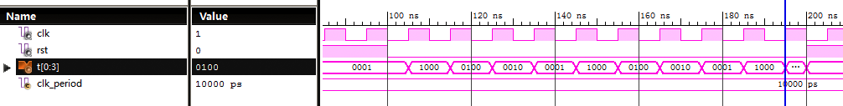

1. 取指管理模块IFctrl

library IEEE;

use IEEE.STD_LOGIC_1164.ALL;

use IEEE.STD_LOGIC_ARITH.ALL;

use IEEE.STD_LOGIC_UNSIGNED.ALL;

entity IFctrl is

Port ( T0 : in STD_LOGIC;

CLK : in STD_LOGIC;

PCnew : in STD_LOGIC_VECTOR (15 downto 0);

IRdata : in STD_LOGIC_VECTOR (15 downto 0); -- 从访存控制模块发来的指令字

PCout : out STD_LOGIC_VECTOR (15 downto 0); -- 发送指令地址

RDIR : out STD_LOGIC; -- 高电平令访存控制模块读指令字

IRout : out STD_LOGIC_VECTOR (15 downto 0)); -- 指令送往其他模块

end IFctrl;

architecture Behavioral of IFctrl is

signal PC, IR : STD_LOGIC_VECTOR(15 downto 0) := X"0000";

signal nextPC : STD_LOGIC_VECTOR(15 downto 0) := X"0000";

begin

RDIR <= T0; -- 控制读指令

process (T0)

begin

if T0 = '1' and T0'event then

PC <= PCnew;

end if;

end process;

PCout <= PC;

IRout <= IRdata when (T0 and CLK) = '1';

end Behavioral;

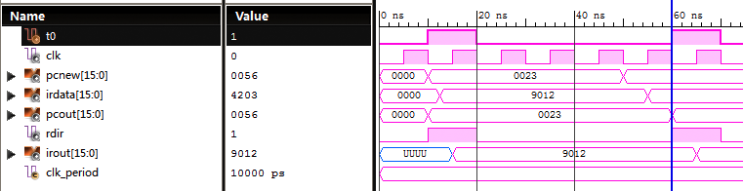

1. 运算管理模块EXctrl

library IEEE;

use IEEE.STD_LOGIC_1164.ALL;

use IEEE.STD_LOGIC_ARITH.ALL;

use IEEE.STD_LOGIC_UNSIGNED.ALL;

entity EXctrl is

Port ( CLK : in STD_LOGIC;

T1 : in STD_LOGIC;

Rupdate : in STD_LOGIC;

Raddr : in STD_LOGIC_VECTOR (2 downto 0);

Rdata : in STD_LOGIC_VECTOR (7 downto 0);

IR : in STD_LOGIC_VECTOR (15 downto 0);

Cout : out std_logic;

R0 : out STD_LOGIC_VECTOR (7 downto 0);

R1 : out STD_LOGIC_VECTOR (7 downto 0);

R2 : out STD_LOGIC_VECTOR (7 downto 0);

R3 : out STD_LOGIC_VECTOR (7 downto 0);

R4 : out STD_LOGIC_VECTOR (7 downto 0);

R5 : out STD_LOGIC_VECTOR (7 downto 0);

R6 : out STD_LOGIC_VECTOR (7 downto 0);

R7 : out STD_LOGIC_VECTOR (7 downto 0);

Addr : out STD_LOGIC_VECTOR (15 downto 0) := X"0000";

ALUOUT : out STD_LOGIC_VECTOR (7 downto 0) := X"00");

end EXctrl;

architecture Behavioral of EXctrl is

type REGARR is array(7 downto 0) of STD_LOGIC_VECTOR(7 downto 0);

signal Reg : REGARR := (X"77", X"66", X"55", X"44", X"33", X"22", X"11", X"00");

signal A, B : STD_LOGIC_VECTOR(7 downto 0) := X"00";

signal Cy : STD_LOGIC := '0';

begin

Cout <= Cy;

R0 <= Reg(0);

R1 <= Reg(1);

R2 <= Reg(2);

R3 <= Reg(3);

R4 <= Reg(4);

R5 <= Reg(5);

R6 <= Reg(6);

R7 <= Reg(7);

-- Prepare A, B, Addr

process (T1, IR)

begin

if T1'event and T1 = '1' then

A <= Reg(conv_integer(IR(10 downto 8)));

B <= Reg(conv_integer(IR(2 downto 0)));

Addr(7 downto 0) <= IR(7 downto 0);

if IR(15 downto 11) = "00010" then -- JZ

Addr(15 downto 8) <= (others => IR(7)); -- 符号位扩展

else

Addr(15 downto 8) <= Reg(7); -- R7扩展寻址

end if;

end if;

end process;

-- Calculate at falling_edge

process (A, B, Cy, IR, T1, CLK)

variable result : STD_LOGIC_VECTOR(8 downto 0);

begin

if T1 = '1' and falling_edge(CLK) then

case IR(15 downto 11) is

when "10100" => Cy <= '0'; -- CLRC(A)

when "10110" => Cy <= '1'; -- SETC(B)

when "00110" => result := (A(7)&A) + (B(7)&B) + Cy; -- ADC(3)

ALUOUT <= result(7 downto 0);

Cy <= result(8); -- 第8位判断进位

when "00100" => result := (A(7)&A) - (B(7)&B) - Cy; -- SBB(2)

ALUOUT <= result(7 downto 0);

Cy <= result(8);

when "01000" => ALUOUT <= IR(7 downto 0); -- MVI(4)

when "01010" => ALUOUT <= B; -- MOV(5)

when "01100" => ALUOUT <= A; -- STA(6)

when "00010" => ALUOUT <= A; -- JZ(1)

when "10010" => ALUOUT <= A; -- OUT(9)

when others => null;

end case;

end if;

end process;

-- Writeback reg

process (Rupdate, Raddr, Rdata)

begin

if Rupdate'event and Rupdate = '1' then

Reg(conv_integer(Raddr)) <= Rdata;

end if;

end process;

end Behavioral;

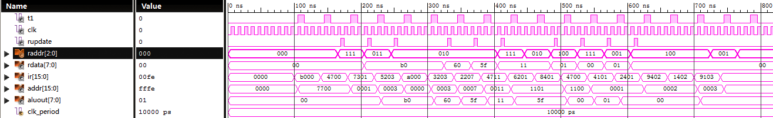

1. 存储管理模块MEMctrl

library IEEE;

use IEEE.STD_LOGIC_1164.ALL;

entity MEMctrl is

Port ( CLK : in STD_LOGIC;

Addrin : in STD_LOGIC_VECTOR (15 downto 0);

Addr : out STD_LOGIC_VECTOR (15 downto 0);

OP : in STD_LOGIC_VECTOR (15 downto 11); -- IR(15 downto 11)

DATA : in STD_LOGIC_VECTOR (7 downto 0);

T2 : in STD_LOGIC;

Rtemp : out STD_LOGIC_VECTOR (7 downto 0);

nMEM : out STD_LOGIC;

nIO : out STD_LOGIC;

RD : out STD_LOGIC;

WR : out STD_LOGIC);

end MEMctrl;

architecture Behavioral of MEMctrl is

begin

-- 送出地址

Addr <= Addrin;

-- 读写控制

nMEM <= '0' when (T2 = '1' and (OP = "01110" or OP = "01100")) else '1';

nIO <= '0' when (T2 = '1' and (OP = "10000" or OP = "10010")) else '1';

WR <= '1' when (T2 = '1' and (OP = "01100" or OP = "10010")) else '0';

RD <= '1' when (T2 = '1' and (OP = "01110" or OP = "10000")) else '0';

-- 更新Rtemp

Rtemp <= DATA when (T2 = '1' and (OP = "01110" or OP = "10000")) else unaffected;

end Behavioral;

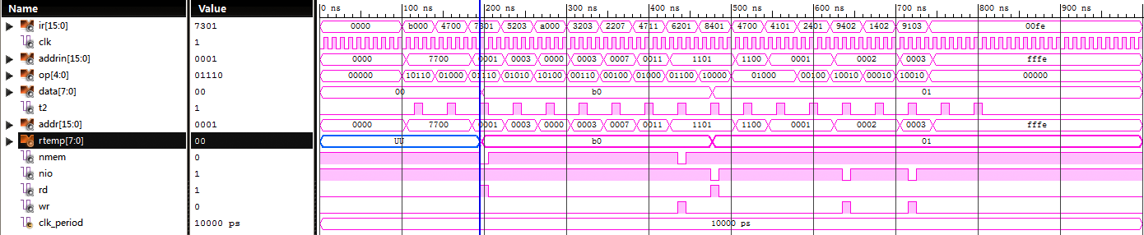

1. 回写管理模块WBctrl

library IEEE;

use IEEE.STD_LOGIC_1164.ALL;

use IEEE.STD_LOGIC_ARITH.ALL;

use IEEE.STD_LOGIC_UNSIGNED.ALL;

entity WBctrl is

Port ( RST : in STD_LOGIC;

Rtemp : in STD_LOGIC_VECTOR (7 downto 0);

PC : in STD_LOGIC_VECTOR (15 downto 0);

Addr : in STD_LOGIC_VECTOR (15 downto 0);

ALUOUT : in STD_LOGIC_VECTOR (7 downto 0);

T3 : in STD_LOGIC;

OP : in STD_LOGIC_VECTOR (15 downto 11); -- IR(15 downto 11)

AD1 : in STD_LOGIC_VECTOR (10 downto 8); -- IR(10 downto 8)

Raddr : out STD_LOGIC_VECTOR (2 downto 0);

Rdata : out STD_LOGIC_VECTOR (7 downto 0);

Rupdate : out STD_LOGIC;

PCnew : out STD_LOGIC_VECTOR (15 downto 0));

end WBctrl;

architecture Behavioral of WBctrl is

begin

-- 提供回写内容

Rdata <= Rtemp when (OP = "10000" or OP = "01110") else -- IN / LDA

ALUOUT;

Raddr <= AD1;

process (RST, OP, ALUOUT, T3)

begin

if RST = '1' then

PCnew <= X"0000";

elsif T3 = '1' and T3'event then

if OP = "00000" then

PCnew <= Addr;

elsif (OP = "00010" and ALUOUT = X"00") then

PCnew <= PC + Addr + 2;

else

PCnew <= PC + 2;

end if;

end if;

end process;

-- 回写控制信号

Rupdate <= '1' when (T3 = '1' and (OP = "10000" or OP = "01110" or OP = "00110" or OP = "00100" or OP = "01010" or OP = "01000")) else '0'; -- IN, LDA, ADC, SBB, MVI, MOV

end Behavioral;

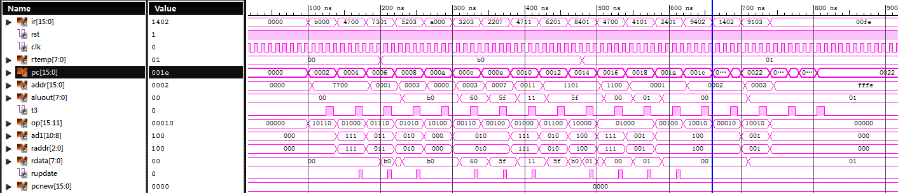

1. 访存控制模块ACctrl

library IEEE;

use IEEE.STD_LOGIC_1164.ALL;

entity ACctrl is

Port ( nIO : in STD_LOGIC;

nMEM : in STD_LOGIC;

RD : in STD_LOGIC;

WR : in STD_LOGIC;

RDIR : in STD_LOGIC;

PC : in STD_LOGIC_VECTOR (15 downto 0);

Addr : in STD_LOGIC_VECTOR (15 downto 0);

ALUOUT : in STD_LOGIC_VECTOR (7 downto 0);

nBLE : out STD_LOGIC;

nBHE : out STD_LOGIC;

ABUS : out STD_LOGIC_VECTOR (15 downto 0);

nRD : out STD_LOGIC;

nWR : out STD_LOGIC;

nMREQ : out STD_LOGIC;

DBUS : inout STD_LOGIC_VECTOR (15 downto 0);

IOAD : out STD_LOGIC_VECTOR (1 downto 0);

IODB : inout STD_LOGIC_VECTOR (7 downto 0);

nPRD : out STD_LOGIC;

nPWR : out STD_LOGIC;

nPREQ : out STD_LOGIC;

IR : out STD_LOGIC_VECTOR (15 downto 0);

Rtemp : out STD_LOGIC_VECTOR (7 downto 0));

end ACctrl;

architecture Behavioral of ACctrl is

signal address : std_logic_vector (15 downto 0);

begin

-- 形成访存/访IO的地址

address <= Addr when (nMEM = '0' or nIO = '0') else

PC when RDIR = '1' else

address;

process (RDIR, WR, RD, nIO, nMEM, DBUS, ALUOUT, IODB, address)

begin

if RDIR = '1' then

nMREQ <= '0';

nBLE <= '0';

nBHE <= '0';

nRD <= '0';

nWR <= '1';

ABUS <= address;

DBUS <= (others => 'Z');

IR <= DBUS;

elsif nMEM = '0' then

nMREQ <= '0';

ABUS <= address;

nBLE <= address(0);

nBHE <= not address(0);

nRD <= not RD;

nWR <= not WR;

if RD = '1' and address(0) = '0' then

DBUS <= (others => 'Z');

Rtemp <= DBUS(7 downto 0);

elsif RD = '1' and address(1) = '0' then

DBUS <= (others => 'Z');

Rtemp <= DBUS(15 downto 8);

elsif WR = '1' then

DBUS <= ALUOUT&ALUOUT;

end if;

elsif nIO = '0' then

nPREQ <= '0';

IOAD <= address(1 downto 0);

nPRD <= not RD;

nPWR <= not WR;

if RD = '1' then

IODB <= (others => 'Z');

Rtemp <= IODB;

elsif WR = '1' then

IODB <= ALUOUT;

end if;

else

nMREQ <= '1';

nPREQ <= '1';

ABUS <= address;

DBUS <= (others => 'Z');

IOAD <= address(1 downto 0);

IODB <= (others => 'Z');

end if;

end process;

end Behavioral;

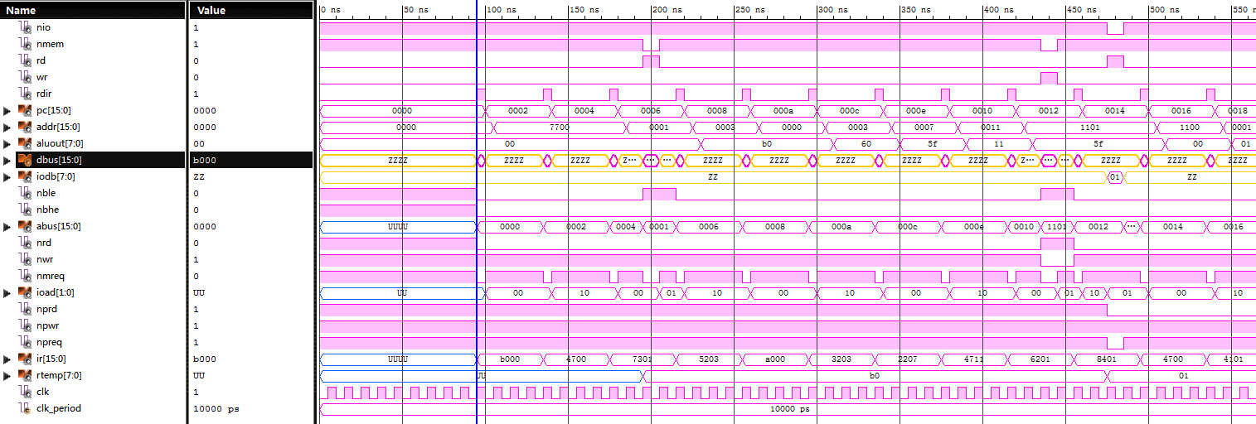

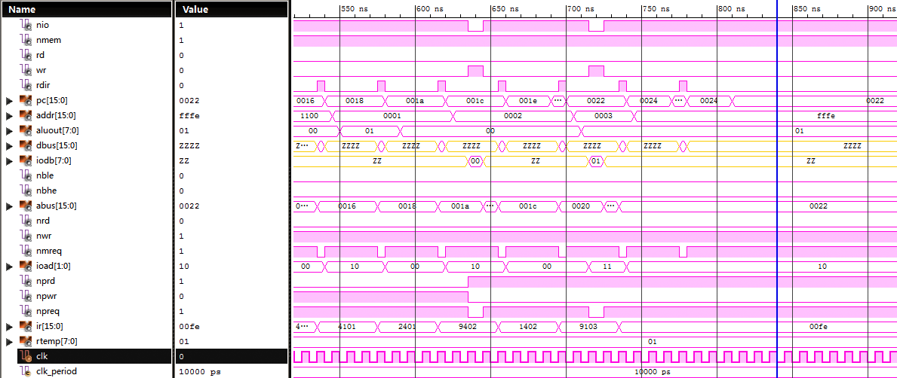

1. 主模块CPU

library IEEE;

use IEEE.STD_LOGIC_1164.ALL;

use IEEE.STD_LOGIC_ARITH.ALL;

use IEEE.STD_LOGIC_UNSIGNED.ALL;

entity CPU is

Port ( RST : in STD_LOGIC;

CLK : in STD_LOGIC;

DBUS : inout STD_LOGIC_VECTOR (15 downto 0);

IODB : inout STD_LOGIC_VECTOR (7 downto 0);

ABUS : out STD_LOGIC_VECTOR (15 downto 0);

IOAD : out STD_LOGIC_VECTOR (1 downto 0);

nMREQ : out STD_LOGIC;

nPREQ : out STD_LOGIC;

nRD : out STD_LOGIC;

nWR : out STD_LOGIC;

nBHE : out STD_LOGIC;

nBLE : out STD_LOGIC;

nPRD : out STD_LOGIC;

nPWR : out STD_LOGIC;

Cout : out STD_LOGIC;

IR : out STD_LOGIC_VECTOR (15 downto 0);

PC : out STD_LOGIC_VECTOR (15 downto 0);

R0 : out STD_LOGIC_VECTOR (7 downto 0);

R1 : out STD_LOGIC_VECTOR (7 downto 0);

R2 : out STD_LOGIC_VECTOR (7 downto 0);

R3 : out STD_LOGIC_VECTOR (7 downto 0);

R4 : out STD_LOGIC_VECTOR (7 downto 0);

R5 : out STD_LOGIC_VECTOR (7 downto 0);

R6 : out STD_LOGIC_VECTOR (7 downto 0);

R7 : out STD_LOGIC_VECTOR (7 downto 0);

T : out STD_LOGIC_VECTOR (3 downto 0));

end CPU;

architecture Behavioral of CPU is

COMPONENT CLKctrl

PORT(

CLK : IN std_logic;

RST : IN std_logic;

T : OUT std_logic_vector(3 downto 0)

);

END COMPONENT;

--///////////////////////////////////////////////

COMPONENT IFctrl

PORT(

T0 : IN std_logic;

CLK : IN std_logic;

PCnew : IN std_logic_vector(15 downto 0);

IRdata : IN std_logic_vector(15 downto 0);

PCout : OUT std_logic_vector(15 downto 0);

RDIR : OUT std_logic;

IRout : OUT std_logic_vector(15 downto 0)

);

END COMPONENT;

--///////////////////////////////////////////////

COMPONENT EXctrl

PORT(

T1 : IN std_logic;

CLK : IN std_logic;

Rupdate : IN std_logic;

Raddr : IN std_logic_vector(2 downto 0);

Rdata : IN std_logic_vector(7 downto 0);

IR : IN std_logic_vector(15 downto 0);

Cout : out std_logic;

R0 : out STD_LOGIC_VECTOR (7 downto 0);

R1 : out STD_LOGIC_VECTOR (7 downto 0);

R2 : out STD_LOGIC_VECTOR (7 downto 0);

R3 : out STD_LOGIC_VECTOR (7 downto 0);

R4 : out STD_LOGIC_VECTOR (7 downto 0);

R5 : out STD_LOGIC_VECTOR (7 downto 0);

R6 : out STD_LOGIC_VECTOR (7 downto 0);

R7 : out STD_LOGIC_VECTOR (7 downto 0);

Addr : OUT std_logic_vector(15 downto 0);

ALUOUT : OUT std_logic_vector(7 downto 0)

);

END COMPONENT;

--///////////////////////////////////////////////

COMPONENT MEMctrl

PORT(

CLK : IN std_logic;

Addrin : IN std_logic_vector(15 downto 0);

Addr : OUT std_logic_vector(15 downto 0);

OP : IN std_logic_vector(4 downto 0);

DATA : IN std_logic_vector(7 downto 0);

T2 : IN std_logic;

Rtemp : OUT std_logic_vector(7 downto 0);

nMEM : OUT std_logic;

nIO : OUT std_logic;

RD : OUT std_logic;

WR : OUT std_logic

);

END COMPONENT;

--///////////////////////////////////////////////

COMPONENT WBctrl

PORT(

RST : IN std_logic;

Rtemp : IN std_logic_vector(7 downto 0);

PC : IN std_logic_vector(15 downto 0);

Addr : IN std_logic_vector(15 downto 0);

ALUOUT : IN std_logic_vector(7 downto 0);

T3 : IN std_logic;

OP : IN std_logic_vector(15 downto 11);

AD1 : IN std_logic_vector(10 downto 8);

Raddr : OUT std_logic_vector(2 downto 0);

Rdata : OUT std_logic_vector(7 downto 0);

Rupdate : OUT std_logic;

PCnew : OUT std_logic_vector(15 downto 0)

);

END COMPONENT;

--///////////////////////////////////////////////

COMPONENT ACctrl

PORT(

nIO : IN std_logic;

nMEM : IN std_logic;

RD : IN std_logic;

WR : IN std_logic;

RDIR : IN std_logic;

PC : IN std_logic_vector(15 downto 0);

Addr : IN std_logic_vector(15 downto 0);

ALUOUT : IN std_logic_vector(7 downto 0);

nBLE : OUT std_logic;

nBHE : OUT std_logic;

ABUS : OUT std_logic_vector(15 downto 0);

nRD : OUT std_logic;

nWR : OUT std_logic;

nMREQ : OUT std_logic;

DBUS : INOUT std_logic_vector(15 downto 0);

IOAD : OUT std_logic_vector(1 downto 0);

IODB : INOUT std_logic_vector(7 downto 0);

nPRD : OUT std_logic;

nPWR : OUT std_logic;

nPREQ : OUT std_logic;

IR : OUT std_logic_vector(15 downto 0);

Rtemp : OUT std_logic_vector(7 downto 0)

);

END COMPONENT;

--///////////////////////////////////////////////

signal Tout : std_logic_vector(3 downto 0) := "1000";

signal RDIR : std_logic;

signal Addrin : std_logic_vector(15 downto 0) := (others => '0');

signal ALUOUT : std_logic_vector(7 downto 0) := (others => '0');

signal Addr : std_logic_vector(15 downto 0) := (others => '0');

signal Rtemp : std_logic_vector(7 downto 0) := (others => '0');

signal nMEM : std_logic := '1';

signal nIO : std_logic := '1';

signal RD : std_logic := '0';

signal WR : std_logic := '0';

signal Raddr : std_logic_vector(2 downto 0) := (others => '0');

signal Rdata : std_logic_vector(7 downto 0) := (others => '0');

signal Rupdate : std_logic := '0';

signal PCnew : std_logic_vector(15 downto 0) := (others => '0');

signal IRdata, IRout, PCout : std_logic_vector(15 downto 0) := (others => '0');

signal Rtempdata : std_logic_vector(7 downto 0) := (others => '0');

begin

comCLK: CLKctrl PORT MAP (

CLK => CLK,

RST => RST,

T => Tout

);

comIF: IFctrl PORT MAP (

T0 => Tout(0),

CLK => CLK,

PCnew => PCnew,

IRdata => IRdata,

PCout => PCout,

RDIR => RDIR,

IRout => IRout

);

comEX: EXctrl PORT MAP (

T1 => Tout(1),

CLK => CLK,

Rupdate => Rupdate,

Raddr => Raddr,

Rdata => Rdata,

IR => IRout,

Cout => Cout,

R0 => R0,

R1 => R1,

R2 => R2,

R3 => R3,

R4 => R4,

R5 => R5,

R6 => R6,

R7 => R7,

Addr => Addrin,

ALUOUT => ALUOUT

);

comMEM: MEMctrl PORT MAP (

CLK => CLK,

Addrin => Addrin,

Addr => Addr,

OP => IRout(15 downto 11),

DATA => Rtempdata,

T2 => Tout(2),

Rtemp => Rtemp,

nMEM => nMEM,

nIO => nIO,

RD => RD,

WR => WR

);

comWB: WBctrl PORT MAP (

RST => RST,

Rtemp => Rtemp,

PC => PCout,

Addr => Addr,

ALUOUT => ALUOUT,

T3 => Tout(3),

OP => IRout(15 downto 11),

AD1 => IRout(10 downto 8),

Raddr => Raddr,

Rdata => Rdata,

Rupdate => Rupdate,

PCnew => PCnew

);

comAC: ACctrl PORT MAP (

nIO => nIO,

nMEM => nMEM,

RD => RD,

WR => WR,

RDIR => RDIR,

PC => PCout,

Addr => Addr,

ALUOUT => ALUOUT,

nBLE => nBLE,

nBHE => nBHE,

ABUS => ABUS,

nRD => nRD,

nWR => nWR,

nMREQ => nMREQ,

DBUS => DBUS,

IOAD => IOAD,

IODB => IODB,

nPRD => nPRD,

nPWR => nPWR,

nPREQ => nPREQ,

IR => IRdata,

Rtemp => Rtempdata

);

PC <= PCout;

IR <= IRout;

T <= Tout;

end Behavioral;

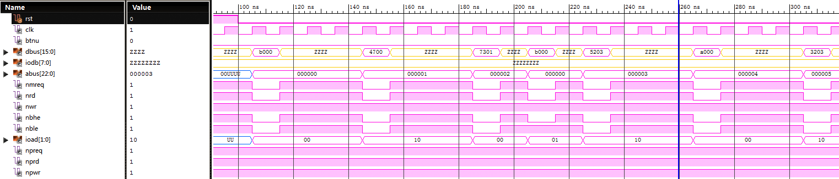

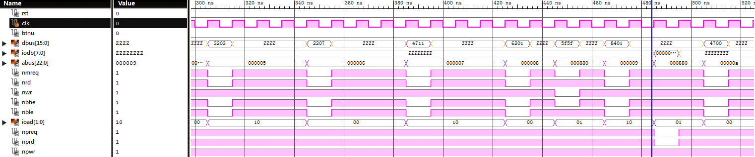

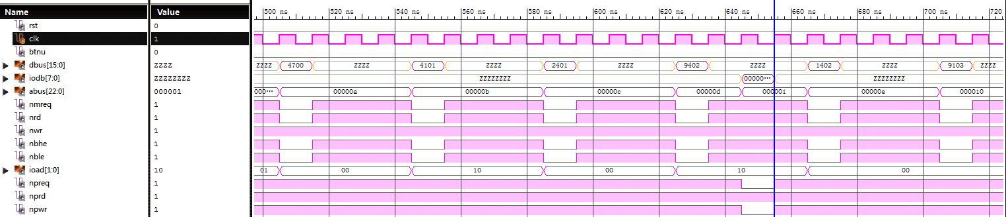

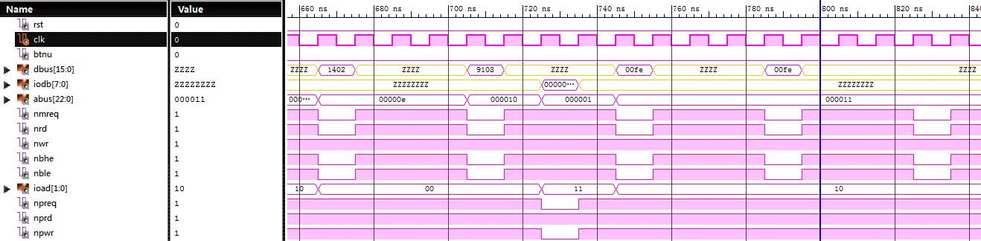

1. 按键防抖模块btnDebounce

library IEEE;

use IEEE.STD_LOGIC_1164.ALL;

use IEEE.STD_LOGIC_ARITH.ALL;

use IEEE.STD_LOGIC_UNSIGNED.ALL;

entity btnDebounce is

Port ( CLK : in STD_LOGIC;

btn : in STD_LOGIC;

btn_deb : out STD_LOGIC);

end btnDebounce;

architecture Behavioral of btnDebounce is

constant CNTR_MAX : std_logic_vector(15 downto 0) := (others => '1');

begin

btn_debounce: process (CLK, btn)

variable count: INTEGER := 0;

begin

if (rising_edge(CLK)) then

if btn = '0' then

if (count = CNTR_MAX) then

count := count;

else

count := count + 1;

end if;

if count = CNTR_MAX - 1 then

btn_deb <= '0';

else

btn_deb <= '1';

end if;

else

count := 0;

end if;

end if;

end process;

end Behavioral;

1. IO转换模块IOConv

library IEEE;

use IEEE.STD_LOGIC_1164.ALL;

entity IOConv is

Port ( IOAD : in STD_LOGIC_VECTOR (1 downto 0);

IODB : inout STD_LOGIC_VECTOR (7 downto 0);

nPREQ : in STD_LOGIC;

nPRD : in STD_LOGIC;

nPWR : in STD_LOGIC;

sw : in STD_LOGIC_VECTOR (7 downto 0);

led : out STD_LOGIC_VECTOR (7 downto 0));

end IOConv;

architecture Behavioral of IOConv is

begin

-- This is a IO device simulator adapted on Nexys3.

-- Address -> device:

-- 00 -> sw(7 downto 0)

-- 01 -> sw(0 to 7)

-- 10 -> led(7 downto 0)

-- 11 -> led(0 to 7)

process (IOAD, IODB, nPREQ, nPRD, nPWR, sw)

begin

IODB <= (others => 'Z');

led <= (others => '0');

if nPREQ = '0' then

if nPRD = '0' and nPWR = '1' then

case IOAD is

when "00" => IODB <= sw;

when "01" =>

rev1: for i in 7 downto 0 loop

IODB(i) <= sw(7-i);

end loop rev1;

when others => null;

end case;

elsif nPRD = '1' and nPWR = '0' then

case IOAD is

when "10" => led <= IODB;

when "11" =>

rev2: for i in 7 downto 0 loop

led(i) <= IODB(7-i);

end loop rev2;

when others => null;

end case;

end if;

end if;

end process;

end Behavioral;

1. 七段数码管显示模块segDisplay

library IEEE;

use IEEE.STD_LOGIC_1164.ALL;

use IEEE.STD_LOGIC_ARITH.ALL;

use IEEE.STD_LOGIC_UNSIGNED.ALL;

entity segDisplay is

Port ( PC : in STD_LOGIC_VECTOR (15 downto 0);

IR : in STD_LOGIC_VECTOR (15 downto 0);

btnu : in STD_LOGIC;

T : in STD_LOGIC_VECTOR (3 downto 0);

clk : in STD_LOGIC;

Cy : in STD_LOGIC;

an : out STD_LOGIC_VECTOR (3 downto 0);

seg : out STD_LOGIC_VECTOR (7 downto 0));

end segDisplay;

architecture Behavioral of segDisplay is

-- seg display control

signal fpclock : STD_LOGIC;

signal js : std_logic_vector(15 downto 0):= (others => '0');

signal shift : STD_LOGIC_VECTOR(3 downto 0) :="0111";

signal digit1, digit2, digit3, digit4 : STD_LOGIC_VECTOR (7 downto 0) := (others => '1');

-- convert 4-bit data into Hexadecimal 7-seg display character

function conv_seg(X : STD_LOGIC_VECTOR) return STD_LOGIC_VECTOR is

begin

case X is

when "0000" => return "1000000"; -- 0

when "0001" => return "1111001";

when "0010" => return "0100100";

when "0011" => return "0110000";

when "0100" => return "0011001";

when "0101" => return "0010010";

when "0110" => return "0000010";

when "0111" => return "1111000";

when "1000" => return "0000000";

when "1001" => return "0010000"; -- 9

when "1010" => return "0001000"; -- A

when "1011" => return "0000011"; -- b

when "1100" => return "1000110"; -- C

when "1101" => return "0100001"; -- d

when "1110" => return "0000110"; -- E

when "1111" => return "0001110"; -- F

when others => return "1111111";

end case;

end conv_seg;

begin

-- Seg display

process(clk)

begin

if(rising_edge(clk)) then

js<=js+'1';

end if;

end process;

fpclock <= js(15);

process(fpclock) -- 7 seg display control

begin

if(fpclock'event and fpclock = '1') then

shift(1)<=shift(0);

shift(2)<=shift(1);

shift(3)<=shift(2);

shift(0)<=shift(3);

an <= shift;

case shift is

when "0111" => seg <= digit1;

when "1011" => seg <= digit2;

when "1101" => seg <= digit3;

when others => seg <= digit4;

end case;

end if;

end process;

digit1 <= (not Cy)&conv_seg(IR(15 downto 12)) when btnu = '1' else (not T(0))&conv_seg(PC(15 downto 12));

digit2 <= (not Cy)&conv_seg(IR(11 downto 8)) when btnu = '1' else (not T(1))&conv_seg(PC(11 downto 8));

digit3 <= (not Cy)&conv_seg(IR(7 downto 4)) when btnu = '1' else (not T(2))&conv_seg(PC(7 downto 4));

digit4 <= (not Cy)&conv_seg(IR(3 downto 0)) when btnu = '1' else (not T(3))&conv_seg(PC(3 downto 0));

end Behavioral;

1. PmodCLP显示模块PmodCLP

library IEEE;

use IEEE.STD_LOGIC_1164.ALL;

use IEEE.STD_LOGIC_ARITH.ALL;

use IEEE.STD_LOGIC_UNSIGNED.ALL;

entity PmodCLP is

Port ( RESET: in std_logic; --use RESET as reset input

clk: in std_logic; --100 MHz clock input

IR: in std_logic_vector(15 downto 0);

R0: in std_logic_vector(7 downto 0);

R1: in std_logic_vector(7 downto 0);

R2: in std_logic_vector(7 downto 0);

R3: in std_logic_vector(7 downto 0);

R4: in std_logic_vector(7 downto 0);

R5: in std_logic_vector(7 downto 0);

R6: in std_logic_vector(7 downto 0);

R7: in std_logic_vector(7 downto 0);

--lcd input signals

--signal on connector JC

JC: out std_logic_vector(7 downto 0); --output bus, used for data transfer (DB)

-- signal on connector JD

--JD(4)register selection pin (RS)

--JD(5)selects between read/write modes (RW)

--JD(6)enable signal for starting the data read/write (E)

JD: out std_logic_vector (6 downto 4)

);

end PmodCLP;

architecture Behavioral of PmodCLP is

------------------------------------------------------------------

-- Local Type Declarations

-----------------------------------------------------------------

-- Symbolic names for all possible states of the state machines.

--LCD control state machine

type mstate is (

stFunctionSet, --Initialization states

stDisplayCtrlSet,

stDisplayClear,

stPowerOn_Delay, --Delay states

stFunctionSet_Delay,

stDisplayCtrlSet_Delay,

stDisplayClear_Delay,

stInitDne, --Display characters and perform standard operations

stActWr,

stCharDelay --Write delay for operations

);

------------------------------------------------------------------

-- Signal Declarations and Constants for PmodCLP

------------------------------------------------------------------

--These constants are used to initialize the LCD pannel.

--FunctionSet:

--Bit 0 and 1 are arbitrary

--Bit 2: Displays font type(0=5x8, 1=5x11)

--Bit 3: Numbers of display lines (0=1, 1=2)

--Bit 4: Data length (0=4 bit, 1=8 bit)

--Bit 5-7 are set

--DisplayCtrlSet:

--Bit 0: Blinking cursor control (0=off, 1=on)

--Bit 1: Cursor (0=off, 1=on)

--Bit 2: Display (0=off, 1=on)

--Bit 3-7 are set

--DisplayClear:

--Bit 1-7 are set

signal clkCount: std_logic_vector (6 downto 0);

signal count: std_logic_vector (20 downto 0):= "000000000000000000000"; --21 bit count variable for timing delays

signal delayOK: std_logic:= '0'; --High when count has reached the right delay time

signal OneUSClk: std_logic; --Signal is treated as a 1 MHz clock

signal stCur: mstate:= stPowerOn_Delay; --LCD control state machine

signal stNext: mstate;

signal writeDone: std_logic:= '0'; --Command set finish

type LCD_CMDS_T is array(0 to 37) of std_logic_vector(9 downto 0);

signal LCD_CMDS : LCD_CMDS_T := ( 0 => "00"&X"3C", --Function Set

1 => "00"&X"0C", --Display ON, Cursor OFF, Blink OFF

2 => "00"&X"01", --Clear Display

3 => "00"&X"02", --return home

4 => "10"&X"20", --blank

5 => "10"&X"20",

6 => "10"&X"20",

7 => "10"&X"20",

8 => "10"&X"20",

9 => "10"&X"20",

10 => "10"&X"20",

11 => "10"&X"20",

12 => "10"&X"20",

13 => "10"&X"20",

14 => "10"&X"20",

15 => "10"&X"20",

16 => "10"&X"20",

17 => "10"&X"20",

18 => "10"&X"20",

19 => "10"&X"20",

20 => "00"&X"C0", --Set DDRAM location to 40H (second row)

21 => "10"&X"20",

22 => "10"&X"20",

23 => "10"&X"20",

24 => "10"&X"20",

25 => "10"&X"20",

26 => "10"&X"20",

27 => "10"&X"20",

28 => "10"&X"20",

29 => "10"&X"20",

30 => "10"&X"20",

31 => "10"&X"20",

32 => "10"&X"20",

33 => "10"&X"20",

34 => "10"&X"20",

35 => "10"&X"20",

36 => "10"&X"20",

37 => "00"&X"02"); --return home

signal lcd_cmd_ptr : integer range 0 to LCD_CMDS'HIGH + 1 := 0;

-- convert 4-bit data into Hexadecimal ascii display character

function conv_ascii(X : STD_LOGIC_VECTOR) return STD_LOGIC_VECTOR is

begin

case X is

when "0000" => return X"30"; -- 0

when "0001" => return X"31";

when "0010" => return X"32";

when "0011" => return X"33";

when "0100" => return X"34";

when "0101" => return X"35";

when "0110" => return X"36";

when "0111" => return X"37";

when "1000" => return X"38";

when "1001" => return X"39"; -- 9

when "1010" => return X"41"; -- A

when "1011" => return X"42"; -- b

when "1100" => return X"43"; -- C

when "1101" => return X"44"; -- d

when "1110" => return X"45"; -- E

when "1111" => return X"46"; -- F

when others => return X"58"; -- X

end case;

end conv_ascii;

begin

--This process counts to 100, and then resets. It is used to divide the clock signal.

--This makes oneUSClock peak aprox. once every 1microsecond

process (CLK)

begin

if (CLK = '1' and CLK'event) then

if(clkCount = "0000001") then -- 修改clkCount可以调节PmodCLP屏幕刷新速度

clkCount <= "0000000";

oneUSClk <= not oneUSClk;

else

clkCount <= clkCount + 1;

end if;

end if;

end process;

--This process increments the count variable unless delayOK = 1.

process (CLK, delayOK)

begin

if (CLK = '1' and CLK'event) then

if delayOK = '1' then

count <= "000000000000000000000";

else

count <= count + 1;

end if;

end if;

end process;

--Determines when count has gotten to the right number, depending on the state.

delayOK <= '1' when ((stCur = stPowerOn_Delay and count = "111101000010010000000") or --2000000 -> 20 ms

(stCur = stFunctionSet_Delay and count = "000000000111110100000") or --4000 -> 40 us

(stCur = stDisplayCtrlSet_Delay and count = "000000000111110100000") or --4000 -> 40 us

(stCur = stDisplayClear_Delay and count = "000100111000100000000") or --160000 -> 1.6 ms

(stCur = stCharDelay and count = "000111111011110100000")) --260000 -> 2.6 ms - Max Delay for character writes and shifts

else '0';

--writeDone goes high when all commands have been run

writeDone <= '1' when (lcd_cmd_ptr = LCD_CMDS'HIGH)

else '0';

--Increments the pointer so the statemachine goes through the commands

process (lcd_cmd_ptr, oneUSClk)

begin

if (oneUSClk = '1' and oneUSClk'event) then

if ((stNext = stInitDne or stNext = stDisplayCtrlSet or stNext = stDisplayClear) and writeDone = '0') then

lcd_cmd_ptr <= lcd_cmd_ptr + 1;

elsif ((stNext = stInitDne or stNext = stDisplayCtrlSet or stNext = stDisplayClear) and writeDone = '1') then

lcd_cmd_ptr <= 4;

elsif stCur = stPowerOn_Delay or stNext = stPowerOn_Delay then

lcd_cmd_ptr <= 0;

else

lcd_cmd_ptr <= lcd_cmd_ptr;

end if;

end if;

end process;

--This process runs the LCD state machine

process (oneUSClk, RESET)

begin

if oneUSClk = '1' and oneUSClk'Event then

if RESET = '1' then

stCur <= stPowerOn_Delay;

else

stCur <= stNext;

end if;

end if;

end process;

--This process generates the sequence of outputs needed to initialize and write to the LCD screen

process (stCur, delayOK, writeDone, lcd_cmd_ptr)

begin

case stCur is

--Delays the state machine for 20ms which is needed for proper startup.

when stPowerOn_Delay =>

if delayOK = '1' then

stNext <= stFunctionSet;

else

stNext <= stPowerOn_Delay;

end if;

--This issues the function set to the LCD as follows

--8 bit data length, 1 lines, font is 5x8.

when stFunctionSet =>

stNext <= stFunctionSet_Delay;

--Gives the proper delay of 37us between the function set and

--the display control set.

when stFunctionSet_Delay =>

if delayOK = '1' then

stNext <= stDisplayCtrlSet;

else

stNext <= stFunctionSet_Delay;

end if;

--Issuse the display control set as follows

--Display ON, Cursor OFF, Blinking Cursor OFF.

when stDisplayCtrlSet =>

stNext <= stDisplayCtrlSet_Delay;

--Gives the proper delay of 37us between the display control set

--and the Display Clear command.

when stDisplayCtrlSet_Delay =>

if delayOK = '1' then

stNext <= stDisplayClear;

else

stNext <= stDisplayCtrlSet_Delay;

end if;

--Issues the display clear command.

when stDisplayClear =>

stNext <= stDisplayClear_Delay;

--Gives the proper delay of 1.52ms between the clear command

--and the state where you are clear to do normal operations.

when stDisplayClear_Delay =>

if delayOK = '1' then

stNext <= stInitDne;

else

stNext <= stDisplayClear_Delay;

end if;

--State for normal operations for displaying characters, changing the

--Cursor position etc.

when stInitDne =>

stNext <= stActWr;

when stActWr =>

stNext <= stCharDelay;

--Provides a max delay between instructions.

when stCharDelay =>

if delayOK = '1' then

stNext <= stInitDne;

else

stNext <= stCharDelay;

end if;

end case;

end process;

--Generate display content according to IR and R0~R7

process (IR, R0, R1, R2, R3, R4, R5, R6, R7)

begin

LCD_CMDS(4) <= "10"&X"20"; -- blank

LCD_CMDS(5) <= "10"&X"20";

LCD_CMDS(6) <= "10"&X"20";

LCD_CMDS(7) <= "10"&X"20";

LCD_CMDS(8) <= "10"&X"20";

LCD_CMDS(9) <= "10"&X"20";

LCD_CMDS(10) <= "10"&X"20";

LCD_CMDS(11) <= "10"&X"20";

LCD_CMDS(12) <= "10"&X"20";

LCD_CMDS(13) <= "10"&X"20";

LCD_CMDS(14) <= "10"&X"20";

LCD_CMDS(15) <= "10"&X"20";

LCD_CMDS(16) <= "10"&X"20";

LCD_CMDS(17) <= "10"&X"20";

LCD_CMDS(18) <= "10"&X"20";

LCD_CMDS(19) <= "10"&X"20";

LCD_CMDS(21) <= "10"&conv_ascii(R0(7 downto 4)); -- R0

LCD_CMDS(22) <= "10"&conv_ascii(R0(3 downto 0));

LCD_CMDS(23) <= "10"&conv_ascii(R1(7 downto 4)); -- R1

LCD_CMDS(24) <= "10"&conv_ascii(R1(3 downto 0));

LCD_CMDS(25) <= "10"&conv_ascii(R2(7 downto 4)); -- R2

LCD_CMDS(26) <= "10"&conv_ascii(R2(3 downto 0));

LCD_CMDS(27) <= "10"&conv_ascii(R3(7 downto 4)); -- R3

LCD_CMDS(28) <= "10"&conv_ascii(R3(3 downto 0));

LCD_CMDS(29) <= "10"&conv_ascii(R4(7 downto 4)); -- R4

LCD_CMDS(30) <= "10"&conv_ascii(R4(3 downto 0));

LCD_CMDS(31) <= "10"&conv_ascii(R5(7 downto 4)); -- R5

LCD_CMDS(32) <= "10"&conv_ascii(R5(3 downto 0));

LCD_CMDS(33) <= "10"&conv_ascii(R6(7 downto 4)); -- R6

LCD_CMDS(34) <= "10"&conv_ascii(R6(3 downto 0));

LCD_CMDS(35) <= "10"&conv_ascii(R7(7 downto 4)); -- R7

LCD_CMDS(36) <= "10"&conv_ascii(R7(3 downto 0));

case IR(15 downto 11) is

when "00000" => -- JMP [R7//0xff]

LCD_CMDS(4)(7 downto 0) <= X"4a";

LCD_CMDS(5)(7 downto 0) <= X"4d";

LCD_CMDS(6)(7 downto 0) <= X"50";

LCD_CMDS(8)(7 downto 0) <= X"5b"; -- [

LCD_CMDS(9)(7 downto 0) <= conv_ascii(R7(7 downto 4)); -- R7

LCD_CMDS(10)(7 downto 0) <= conv_ascii(R7(3 downto 0)); -- R7

LCD_CMDS(11)(7 downto 0) <= X"2f"; -- /

LCD_CMDS(12)(7 downto 0) <= X"2f"; -- /

LCD_CMDS(13)(7 downto 0) <= X"30"; -- 0

LCD_CMDS(14)(7 downto 0) <= X"78"; -- x

LCD_CMDS(15)(7 downto 0) <= conv_ascii(IR(7 downto 4));

LCD_CMDS(16)(7 downto 0) <= conv_ascii(IR(3 downto 0));

LCD_CMDS(17)(7 downto 0) <= X"5d";

when "00010" => -- JZ Rx, 0xffff

LCD_CMDS(4)(7 downto 0) <= X"4a";

LCD_CMDS(5)(7 downto 0) <= X"5a";

LCD_CMDS(7)(7 downto 0) <= X"52";

LCD_CMDS(8)(7 downto 0) <= "00110"&IR(10 downto 8);

LCD_CMDS(9)(7 downto 0) <= X"2c"; -- ,

LCD_CMDS(11)(7 downto 0) <= X"30"; -- 0

LCD_CMDS(12)(7 downto 0) <= X"78"; -- x

LCD_CMDS(13)(7 downto 0) <= conv_ascii(IR(7)&IR(7)&IR(7)&IR(7)); -- sign

LCD_CMDS(14)(7 downto 0) <= conv_ascii(IR(7)&IR(7)&IR(7)&IR(7)); -- sign

LCD_CMDS(15)(7 downto 0) <= conv_ascii(IR(7 downto 4));

LCD_CMDS(16)(7 downto 0) <= conv_ascii(IR(3 downto 0));

when "00100" => -- SBB Rx, Rx

LCD_CMDS(4)(7 downto 0) <= X"53";

LCD_CMDS(5)(7 downto 0) <= X"42";

LCD_CMDS(6)(7 downto 0) <= X"42";

LCD_CMDS(8)(7 downto 0) <= X"52";

LCD_CMDS(9)(7 downto 0) <= "00110"&IR(10 downto 8);

LCD_CMDS(10)(7 downto 0) <= X"2c";

LCD_CMDS(12)(7 downto 0) <= X"52";

LCD_CMDS(13)(7 downto 0) <= "00110"&IR(2 downto 0);

when "00110" => -- ADC Rx, Rx

LCD_CMDS(4)(7 downto 0) <= X"41";

LCD_CMDS(5)(7 downto 0) <= X"44";

LCD_CMDS(6)(7 downto 0) <= X"43";

LCD_CMDS(8)(7 downto 0) <= X"52";

LCD_CMDS(9)(7 downto 0) <= "00110"&IR(10 downto 8);

LCD_CMDS(10)(7 downto 0) <= X"2c";

LCD_CMDS(12)(7 downto 0) <= X"52";

LCD_CMDS(13)(7 downto 0) <= "00110"&IR(2 downto 0);

when "01000" => -- MVI Rx, 0xff

LCD_CMDS(4)(7 downto 0) <= X"4d";

LCD_CMDS(5)(7 downto 0) <= X"56";

LCD_CMDS(6)(7 downto 0) <= X"49";

LCD_CMDS(8)(7 downto 0) <= X"52";

LCD_CMDS(9)(7 downto 0) <= "00110"&IR(10 downto 8);

LCD_CMDS(10)(7 downto 0) <= X"2c";

LCD_CMDS(12)(7 downto 0) <= X"30";

LCD_CMDS(13)(7 downto 0) <= X"78";

LCD_CMDS(14)(7 downto 0) <= conv_ascii(IR(7 downto 4));

LCD_CMDS(15)(7 downto 0) <= conv_ascii(IR(3 downto 0));

when "01010" => -- MOV Rx, Rx

LCD_CMDS(4)(7 downto 0) <= X"4d";

LCD_CMDS(5)(7 downto 0) <= X"4f";

LCD_CMDS(6)(7 downto 0) <= X"56";

LCD_CMDS(8)(7 downto 0) <= X"52";

LCD_CMDS(9)(7 downto 0) <= "00110"&IR(10 downto 8);

LCD_CMDS(10)(7 downto 0) <= X"2c";

LCD_CMDS(12)(7 downto 0) <= X"52";

LCD_CMDS(13)(7 downto 0) <= "00110"&IR(2 downto 0);

when "01100" => -- STA Rx, [0xff]

LCD_CMDS(4)(7 downto 0) <= X"53";

LCD_CMDS(5)(7 downto 0) <= X"54";

LCD_CMDS(6)(7 downto 0) <= X"41";

LCD_CMDS(8)(7 downto 0) <= X"52";

LCD_CMDS(9)(7 downto 0) <= "00110"&IR(10 downto 8);

LCD_CMDS(10)(7 downto 0) <= X"2c";

LCD_CMDS(12)(7 downto 0) <= X"5b";

LCD_CMDS(13)(7 downto 0) <= X"30";

LCD_CMDS(14)(7 downto 0) <= X"78";

LCD_CMDS(15)(7 downto 0) <= conv_ascii(IR(7 downto 4));

LCD_CMDS(16)(7 downto 0) <= conv_ascii(IR(3 downto 0));

LCD_CMDS(17)(7 downto 0) <= X"5d";

when "01110" => -- LDA Rx, [0xff]

LCD_CMDS(4)(7 downto 0) <= X"4c";

LCD_CMDS(5)(7 downto 0) <= X"44";

LCD_CMDS(6)(7 downto 0) <= X"41";

LCD_CMDS(8)(7 downto 0) <= X"52";

LCD_CMDS(9)(7 downto 0) <= "00110"&IR(10 downto 8);

LCD_CMDS(10)(7 downto 0) <= X"2c";

LCD_CMDS(12)(7 downto 0) <= X"5b";

LCD_CMDS(13)(7 downto 0) <= X"30";

LCD_CMDS(14)(7 downto 0) <= X"78";

LCD_CMDS(15)(7 downto 0) <= conv_ascii(IR(7 downto 4));

LCD_CMDS(16)(7 downto 0) <= conv_ascii(IR(3 downto 0));

LCD_CMDS(17)(7 downto 0) <= X"5d";

when "10000" => -- IN Rx, [00]

LCD_CMDS(4)(7 downto 0) <= X"49";

LCD_CMDS(5)(7 downto 0) <= X"4e";

LCD_CMDS(7)(7 downto 0) <= X"52";

LCD_CMDS(8)(7 downto 0) <= "00110"&IR(10 downto 8);

LCD_CMDS(9)(7 downto 0) <= X"2c";

LCD_CMDS(11)(7 downto 0) <= X"5b";

LCD_CMDS(12)(7 downto 0) <= conv_ascii("000"&IR(1));

LCD_CMDS(13)(7 downto 0) <= conv_ascii("000"&IR(0));

LCD_CMDS(14)(7 downto 0) <= X"5d";

when "10010" => -- OUT Rx, [00]

LCD_CMDS(4)(7 downto 0) <= X"4f";

LCD_CMDS(5)(7 downto 0) <= X"55";

LCD_CMDS(6)(7 downto 0) <= X"54";

LCD_CMDS(8)(7 downto 0) <= X"52";

LCD_CMDS(9)(7 downto 0) <= "00110"&IR(10 downto 8);

LCD_CMDS(10)(7 downto 0) <= X"2c";

LCD_CMDS(12)(7 downto 0) <= X"5b";

LCD_CMDS(13)(7 downto 0) <= conv_ascii("000"&IR(1));

LCD_CMDS(14)(7 downto 0) <= conv_ascii("000"&IR(0));

LCD_CMDS(15)(7 downto 0) <= X"5d";

when "10100" => -- CLRC

LCD_CMDS(4)(7 downto 0) <= X"43";

LCD_CMDS(5)(7 downto 0) <= X"4c";

LCD_CMDS(6)(7 downto 0) <= X"52";

LCD_CMDS(7)(7 downto 0) <= X"43";

when "10110" => -- SETC

LCD_CMDS(4)(7 downto 0) <= X"53";

LCD_CMDS(5)(7 downto 0) <= X"45";

LCD_CMDS(6)(7 downto 0) <= X"54";

LCD_CMDS(7)(7 downto 0) <= X"43";

when others => -- Undefined... >_<

LCD_CMDS(4)(7 downto 0) <= X"55";

LCD_CMDS(5)(7 downto 0) <= X"6e";

LCD_CMDS(6)(7 downto 0) <= X"64";

LCD_CMDS(7)(7 downto 0) <= X"65";

LCD_CMDS(8)(7 downto 0) <= X"66";

LCD_CMDS(9)(7 downto 0) <= X"69";

LCD_CMDS(10)(7 downto 0) <= X"6e";

LCD_CMDS(11)(7 downto 0) <= X"65";

LCD_CMDS(12)(7 downto 0) <= X"64";

LCD_CMDS(13)(7 downto 0) <= X"2e";

LCD_CMDS(14)(7 downto 0) <= X"2e";

LCD_CMDS(16)(7 downto 0) <= X"3e";

LCD_CMDS(17)(7 downto 0) <= X"5f";

LCD_CMDS(18)(7 downto 0) <= X"3c";

end case;

end process;

JD(4) <= LCD_CMDS(lcd_cmd_ptr)(9);

JD(5) <= LCD_CMDS(lcd_cmd_ptr)(8);

JC <= LCD_CMDS(lcd_cmd_ptr)(7 downto 0);

JD(6) <= '1' when stCur = stFunctionSet or stCur = stDisplayCtrlSet or stCur = stDisplayClear or stCur = stActWr

else '0';

end Behavioral;

1. 总模块N3Adapter

library IEEE;

use IEEE.STD_LOGIC_1164.ALL;

use IEEE.STD_LOGIC_ARITH.ALL;

use IEEE.STD_LOGIC_UNSIGNED.ALL;

entity N3Adapter is

Port ( CLK: in STD_LOGIC;

sw : in STD_LOGIC_VECTOR (7 downto 0);

led : out STD_LOGIC_VECTOR (7 downto 0);

btnr : in STD_LOGIC;

btns : in STD_LOGIC;

btnu : in STD_LOGIC;

an : out STD_LOGIC_VECTOR (3 downto 0);

seg : out STD_LOGIC_VECTOR (7 downto 0);

--signal on connector JC

JC: out std_logic_vector(7 downto 0); --output bus, used for data transfer (DB)

-- signal on connector JD

--JD(4)register selection pin (RS)

--JD(5)selects between read/write modes (RW)

--JD(6)enable signal for starting the data read/write (E)

JD: out std_logic_vector (6 downto 4);

MemOE : out STD_LOGIC;

MemWR : out STD_LOGIC;

MemAdv : out STD_LOGIC;

MemWait : out STD_LOGIC;

MemClk : out STD_LOGIC;

RamCS : out STD_LOGIC;

RamCRE : out STD_LOGIC;

RamUB : out STD_LOGIC;

RamLB : out STD_LOGIC;

MemAdr : out STD_LOGIC_VECTOR (26 downto 1);

MemDB : inout STD_LOGIC_VECTOR (15 downto 0));

end N3Adapter;

architecture Behavioral of N3Adapter is

------------------------------------------------------------------

-- Component Declarations

------------------------------------------------------------------

component CPU

Port ( RST : in STD_LOGIC;

CLK : in STD_LOGIC;

DBUS : inout STD_LOGIC_VECTOR (15 downto 0);

IODB : inout STD_LOGIC_VECTOR (7 downto 0);

ABUS : out STD_LOGIC_VECTOR (15 downto 0);

IOAD : out STD_LOGIC_VECTOR (1 downto 0);

nMREQ : out STD_LOGIC;

nPREQ : out STD_LOGIC;

nRD : out STD_LOGIC;

nWR : out STD_LOGIC;

nBHE : out STD_LOGIC;

nBLE : out STD_LOGIC;

nPRD : out STD_LOGIC;

nPWR : out STD_LOGIC;

Cout : out std_logic;

IR : out STD_LOGIC_VECTOR (15 downto 0);

PC : out STD_LOGIC_VECTOR (15 downto 0);

R0 : out STD_LOGIC_VECTOR (7 downto 0);

R1 : out STD_LOGIC_VECTOR (7 downto 0);

R2 : out STD_LOGIC_VECTOR (7 downto 0);

R3 : out STD_LOGIC_VECTOR (7 downto 0);

R4 : out STD_LOGIC_VECTOR (7 downto 0);

R5 : out STD_LOGIC_VECTOR (7 downto 0);

R6 : out STD_LOGIC_VECTOR (7 downto 0);

R7 : out STD_LOGIC_VECTOR (7 downto 0);

T : out STD_LOGIC_VECTOR (3 downto 0));

end component;

component IOConv

Port ( IOAD : in STD_LOGIC_VECTOR (1 downto 0);

IODB : inout STD_LOGIC_VECTOR (7 downto 0);

nPREQ : in STD_LOGIC;

nPRD : in STD_LOGIC;

nPWR : in STD_LOGIC;

sw : in STD_LOGIC_VECTOR (7 downto 0);

led : out STD_LOGIC_VECTOR (7 downto 0));

end component;

component btnDebounce

Port ( CLK : in std_logic;

btn : in std_logic;

btn_deb : out std_logic);

end component;

component PmodCLP

Port ( RESET: in std_logic; --use BTNS as reset input

CLK: in std_logic; --100 MHz clock input

IR: in std_logic_vector(15 downto 0);

R0: in std_logic_vector(7 downto 0);

R1: in std_logic_vector(7 downto 0);

R2: in std_logic_vector(7 downto 0);

R3: in std_logic_vector(7 downto 0);

R4: in std_logic_vector(7 downto 0);

R5: in std_logic_vector(7 downto 0);

R6: in std_logic_vector(7 downto 0);

R7: in std_logic_vector(7 downto 0);

--lcd input signals

--signal on connector JC

JC: out std_logic_vector(7 downto 0); --output bus, used for data transfer (DB)

-- signal on connector JD

--JD(4)register selection pin (RS)

--JD(5)selects between read/write modes (RW)

--JD(6)enable signal for starting the data read/write (E)

JD: out std_logic_vector (6 downto 4)

);

end component;

component segDisplay

Port ( PC : in STD_LOGIC_VECTOR (15 downto 0);

IR : in STD_LOGIC_VECTOR (15 downto 0);

btnu : in STD_LOGIC;

T : in STD_LOGIC_VECTOR (3 downto 0);

clk : in STD_LOGIC;

Cy : in STD_LOGIC;

an : out STD_LOGIC_VECTOR (3 downto 0);

seg : out STD_LOGIC_VECTOR (7 downto 0));

end component;

------------------------------------------------------------------

-- Local Type Declarations

-----------------------------------------------------------------

-- For CPU

signal T : std_logic_vector(3 downto 0);

signal IR : STD_LOGIC_VECTOR (15 downto 0);

signal PC : STD_LOGIC_VECTOR (15 downto 0);

signal Cout : std_logic;

signal R0 : STD_LOGIC_VECTOR (7 downto 0);

signal R1 : STD_LOGIC_VECTOR (7 downto 0);

signal R2 : STD_LOGIC_VECTOR (7 downto 0);

signal R3 : STD_LOGIC_VECTOR (7 downto 0);

signal R4 : STD_LOGIC_VECTOR (7 downto 0);

signal R5 : STD_LOGIC_VECTOR (7 downto 0);

signal R6 : STD_LOGIC_VECTOR (7 downto 0);

signal R7 : STD_LOGIC_VECTOR (7 downto 0);

signal ABUS : STD_LOGIC_VECTOR (15 downto 0);

signal nRD : STD_LOGIC;

signal nWR : STD_LOGIC;

-- This signals are for IO controller.

signal IODB : std_logic_vector(7 downto 0);

signal IOAD : std_logic_vector(1 downto 0);

signal nPREQ, nPRD, nPWR : std_logic;

-- Debounce btnr

signal btnr_deb : std_logic;

begin

comBtnrDeb: btnDebounce port map(

CLK => CLK,

btn => btnr,

btn_deb => btnr_deb);

comPmodCLP: PmodCLP port map(

RESET => btns,

CLK => CLK,

IR => IR,

R0 => R0,

R1 => R1,

R2 => R2,

R3 => R3,

R4 => R4,

R5 => R5,

R6 => R6,

R7 => R7,

JC => JC,

JD => JD);

comCPU: CPU port map(

RST => btns,

CLK => btnr_deb,

DBUS => MemDB,

IODB => IODB,

ABUS => ABUS,

IOAD => IOAD,

nMREQ => RamCS,

nPREQ => nPREQ,

nRD => MemOE,

nWR => MemWR,

nBHE => RamUB,

nBLE => RamLB,

nPRD => nPRD,

nPWR => nPWR,

Cout => Cout,

IR => IR,

PC => PC,

R0 => R0,

R1 => R1,

R2 => R2,

R3 => R3,

R4 => R4,

R5 => R5,

R6 => R6,

R7 => R7,

T => T);

comIOConv: IOConv port map(

IOAD => IOAD,

IODB => IODB,

nPREQ => nPREQ,

nPRD => nPRD,

nPWR => nPWR,

sw => sw,

led => led);

comsegDisplay: segDisplay port map(

T => T,

PC => PC,

IR => IR,

btnu => btnu,

Cy => Cout,

clk => clk,

an => an,

seg => seg);

MemAdv <= '0';

MemWait <= '0';

MemClk <= '0';

RamCRE <= '0';

MemAdr(26 downto 16) <= (others => '0');

MemAdr(15 downto 1) <= ABUS(15 downto 1);

end Behavioral;

# 问题与解决方案

下面介绍一下在设计、调试、波形、下载过程中遇到的问题及解决方法。

1. 一个节拍内可能要做多件事，比如T1节拍，既要准备好A、B、Addr的值，又要根据A、B、Cy的值计算出结果，这两件事有先后顺序，而如果只由T1一个信号控制的话，先后顺序不好处理。

解决办法：将CLK时钟信号引入，一个节拍就可以分成前半拍（CLK=’1’）和后半拍（CLK=’0’）。可以在节拍的上升沿做前一件事，在CLK的下降沿做另一件事，顺序就很清楚了。

1. 取指模块取到的指令不对；访存模块在写内存时改变了不应改变的（前一次访问的）数据。

解决办法：取到的指令不对，可以把IR的赋值从边沿触发改为电平触发，在T0 and CLK高电平时让IR跟随IRdata，这样就不会出现要取的数据还没出现在数据线上就被取走的情况。也可以提前送地址，后取数据。写数据时将数据写乱也可能是这个原因，写信号的给出先于地址的给出，导致先写到了上一次地址总线所指的地方，又写到了正确的地方。

1. 系统仿真时看到波形中数据线上出现一堆红色的“X”。

解决办法：问题的原因有很多，如读写的时序有问题，但最有可能也最容易解决的是，在读数据时没有将数据总线赋高阻。数据总线是三态总线，使用一个方向时，另一个方向必须赋高阻。如果输出不赋高阻，还要读取数据，那么数据总线上的数据就是0、1混淆的，也就是X。

1. 仿真一切都对，但是下载到板子上PC就是不加一。

解决办法：这是一个非常常见也非常棘手的问题，据我了解，几乎所有人，包括我，最后都采用了同一个解决办法，就是把PC+1从取指模块改到回写模块。我取消了PCupdate信号，让回写模块中的PCnew来表示加一后的PC或跳转到的PC值，然后让取指模块在T0上升沿把PCnew更新到PC。这样就避开了取指模块既修改PC又送PC访存的麻烦，改完以后，程序运行马上就变得一切正常了。

1. 下载到板子上以后，发现读到的指令或数据有时是正确的，有时又是0x0006或0x6666。

解决办法：这是使用N3开发板的同学很容易遇到的问题，究其原因，还是访存的时序没有控制好，数据有时是对的，有时是错的，说明逻辑没错，但实现得不好，不稳定。建议把访存模块换一种方法重写一遍，对于解决疑难bug有奇效。

# 总结

本文设计并实现了一个基于Digilent® Nexys 3™开发板的单进程、精简指令集CPU。该CPU采用四个节拍控制指令周期完成一条指令，结构清晰，实现起来并不复杂，但要真正使其正常工作，还是需要大量的调试工作。在这次开发过程中，我经历了巨大的困难，连续几天熬到凌晨四五点，只为了改好一个个的bug。奋斗的过程是痛苦的，但成功后的喜悦是巨大的。当我成功在开发板上运行了自己设计的程序，并将每条指令和寄存器数据显示在PmodCLP上的时候，那种欣慰告诉我，这些付出是值得的。我不仅学到了硬件设计的入门知识，还极大地加深了对于计算机底层设计和运行机制的理解，这些收获，如果不亲自做一个CPU的话，是不可能有的。最后我想说，虽然这个CPU做完了，看起来也运行得很好，但是我知道，他一定还存在着许多缺陷，存在着很多我没有发现的问题。越学习，就越明白自己的浅薄，接下来，我会以更加虚心的态度，不仅在计算机这个领域中，也要在各种知识和人文素养上，做一个不那么浅薄的人。这篇报告在上交老师的同时，也发在了我的博客中，文中有诸多不当之处，还请不吝赐教。

